

**AFA DATA VALIDATION & REPORT WRITING NAKURU**

**13TH - 18TH MARCH, 2017**

**Introduction**

Agriculture and Food Authority (AFA) is the regulator of the Kenyan agricultural sector as provided by the provisions of the AFA Act No. 25 of 2013 and the Crops Act No. 16 of 2013. While the AFA Act mandates the Authority to collect and collate data and maintain a database on agricultural products, the Crops Act reinforces this provision by requiring the Authority to maintain the necessary statistical information with respect to the scheduled crops to enable proper and efficient planning.

AFA currently is comprised of eight Directorates.

* Tea Directorate
* Coffee Directorate
* Sugar Directorate
* Horticultural Crops Directorate
* Pyrethrum & other industrial crops Directorate
* Nuts and Oil Crops Directorate
* Fibre Crops Directorate
* Food Directorate

The critical nature of reliable data cannot be underestimated in the planning purposes. Accurate data leads to well informed decision making process. To improve the collection and collation of data, the authority is working very closely with the Ministry of Agriculture Livestock and Fisheries (MoALF) and the Kenya National Bureau of statistics (KNBS) in setting up a national one stop database that will contain all agricultural data for all the scheduled crops.

1. **Tea**

The area planted with tea increased by 4 per cent from 209.4 thousand hectares in 2015 to 218.5 thousand hectares in 2016. During the same period, tea production increased by 16 per cent from 399.21 thousand tons in 2015 to 473.01 thousand tons. Compared to 2016, the Smallholder sub-sector registered production increase of 11 per cent from 237.5 thousand tons to 265.6 thousand tons. Output within the Estate sub-sector recorded an increase of 22 per cent from 161.6 thousand tons to 207.4 thousand tons.

Figure 1: Tea Planted Area

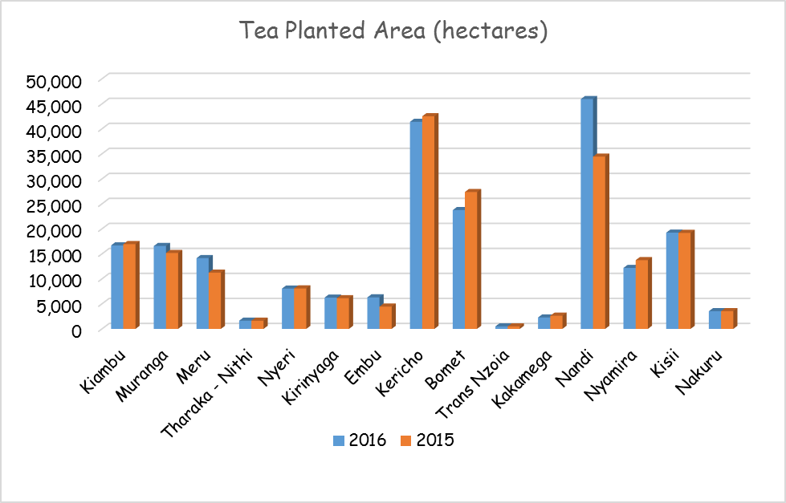

***Source: AFA, Tea Directorate***

Consequently, the average yield increased from 2459 kg/ha to 2788 kg/ha for the Estate sub-sector and from 1926 kg/ha to 2065 kg/ha for the Smallholder sub-sector. Higher production and productivity was attributed to continued good weather conditions, following the 2015 El-Nino induced “short rains” that continued into the first quarter of 2016 as well as enhanced and well distributed rainfall experienced during the 2016 April-May “long rains” season.

*Table 1: Area under Tea and Production Trend (2016-2015)*

|  |  |  |  |  |
| --- | --- | --- | --- | --- |
| **COUNTY** | **PLANTED AREA (Ha)** | | **MADE TEA (000 Kgs)** | |
| **2016** | **2015** | **2016** | **2015** |
| KIAMBU | 16,689.26 | 16,944.42 | 40,085 | 37,517 |
| MURANGA | 16,575.86 | 15,172.32 | 45,711 | 42,986 |
| MERU | 14,152.05 | 11,241.36 | 26,669 | 25,680 |
| THARAKA - NITHI | 1,639.65 | 1,625.96 | 4,072 | 3,772 |
| NYERI | 8,059.32 | 8,090.70 | 21,116 | 19,081 |
| KIRINYAGA | 6,256.50 | 6,135.84 | 18,435 | 17,576 |
| EMBU | 6,301.36 | 4,455.10 | 12,261 | 11,061 |
| KERICHO | 41,403.36 | 42,512.78 | 93,160 | 65,657 |
| BOMET | 23,753.87 | 27,360.84 | 72,708 | 62,027 |
| TRANS NZOIA | 495.5 | 495.5 | 3,121 | 1,763 |
| KAKAMEGA | 2,284.22 | 2,634.12 | 2,772 | 3,015 |
| NANDI | 45,952.92 | 34,442.66 | 71,564 | 57,262 |
| NYAMIRA | 12,187.36 | 13,743.00 | 28,700 | 22,762 |
| KISII | 19,240.52 | 19,196.00 | 26,822 | 24,126 |
| NAKURU | 3,546.48 | 3,546.48 | 5,807 | 4,923 |
| Total | 218,538.23 | 207,597.08 | 473,003 | 399,208 |

***Source: AFA - Tea Directorate***

**Tea Auction**

Owing to higher supplies coupled with slacked demand for black tea in traditional markets occasioned by continued pressure against the local currencies by the US Dollar, Kenya tea prices recorded a downward trend. During the year, the average Auction prices for Kenya tea were lower at 2.36 USD per Kg compared to 2.98 recorded in 2015.

**Tea Exports**

Tea exports and re-exports volumes were higher by 8% from 443.46 thousand tons recorded in 2015 to 480.33 thousand tons. Owing to lower prices, the export earnings dropped to 120.69 Billion from 125.25 Billion recorded in 2015.

**Local Consumption**

Local tea consumption higher by 1.30% from 29.37 recorded in 2015 to 29.75 Million Kgs.

1. **Coffee**

**Coffee Production and Area under Coffee**

Coffee production increased by 10 per cent from 42,038 metric tonnes recorded in 2014/15 to 46,121 metric tonnes recorded in 2015/16. This is expected because it followed the cyclic nature of coffee production. This is attributed to low farm input use especially fertilizer and poor tree management. This cyclic trend is expected to be even out through improved production and productivity with support from the national and county governments through provision of subsidized farm inputs (fertilizer and seedlings), capacity building of growers.

Similarly, the approximated area under coffee increased marginally by 640 hectares from 113,761 hectares recorded in 2015 to 114,401 hectares recorded in 2016. The increase is mainly attributed to more planting of coffee by the county governments of Kericho, Elgeyo Marakwet, Nandi, Trans Nzoia, Migori, Bomet and Bungoma through the ICPI initiative which is meant to increase the area under coffee in traditional and non-traditional area as well as increase in productivity.

*Table 2: Area under Coffee and Production*

|  |  |  |  |  |  |  |  |  |
| --- | --- | --- | --- | --- | --- | --- | --- | --- |
| **COUNTY** | **Production (MT)** | | **Area (Ha) 2015-2016** | | | **Area(Ha) 2014-2015** | | |
| **2015 -2016** | **2014 -2015** | **Estate** | **Co -operatives** | **Total** | **Estate** | **Co-operatives** | **Total** |
| KIAMBU | 12,793 | 11,345 | 12,814 | 10,830 | **23,644** | 12,814 | 10,830 | **23,644** |
| NYERI | 7,541 | 5,656 | 1,024 | 12,448 | **13,472** | 1,024 | 12,448 | **13,472** |
| KIRINYAGA | 6,193 | 4,638 | 1,590 | 6,253 | **7,843** | 1,590 | 6,245 | **7,835** |
| MURANGA | 5,830 | 3,508 | 4,602 | 13,912 | **18,514** | 4,602 | 13,912 | **18,514** |
| EMBU | 2,075 | 2,003 | 336 | 6,499 | **6,835** | 336 | 6,499 | **6,835** |
| BUNGOMA | 1,289 | 1,247 | 183 | 6,280 | **6,463** | 183 | 6,230 | **6,413** |
| MERU | 1,731 | 3,975 | 826 | 7,716 | **8,542** | 826 | 7,646 | **8,472** |
| KERICHO | 1,448 | 1,829 | 90 | 2,380 | **2,470** | 72 | 2,230 | **2,302** |
| MACHAKOS | 1,955 | 2,329 | 1,547 | 6,060 | **7,607** | 1,547 | 6,060 | **7,607** |
| KISII | 1,415 | 1,092 | 101 | 3,765 | **3,866** | 101 | 3,765 | **3,866** |
| MAKUENI | 68 | 174 | 27 | 2,007 | **2,034** | 27 | 2,007 | **2,034** |
| THARAKA-NITHI | 863 | 1,386 | 255 | 3,412 | **3,667** | 255 | 3,412 | **3,667** |
| NYAMIRA | 1,019 | 887 | 36 | 1,910 | **1,946** | 36 | 1,910 | **1,946** |
| TRANS NZOIA | 403 | 642 | 1,625 | 270 | **1,895** | 1,550 | 255 | **1,805** |
| NAKURU | 799 | 626 | 1,480 | 525 | **2,005** | 1,480 | 450 | **1,930** |
| NANDI | 384 | 419 | 71 | 635 | **706** | 62 | 465 | **527** |
| UASIN GISHU | 47 | 18 | 81 | 55 | **136** | 81 | 55 | **136** |
| MIGORI | 75 | 40 | - | 755 | **755** | - | 755 | **755** |
| HOMA BAY | 32 | 31 | - | 410 | **410** | - | 410 | **410** |
| BOMET | 14 | 8 | 40 | 136 | **176** | 40 | 136 | **176** |
| BARINGO | 78 | 89 | 146 | 677 | **823** | 146 | 677 | **823** |
| WEST POKOT | 17 | 31 | 5 | 79 | **79** | - | 84 | **84** |
| ELGEYO MARAKWET | 21 | 22 | 8 | 52 | **60** | 8 | 52 | **60** |
| LAIKIPIA | 7 | 9 | 4 | 36 | **40** | 4 | 36 | **40** |
| NAROK | - | - | 3 | - | **3** | 3 | - | **3** |
| KISUMU | 3 | 3 | 56 | 8 | **64** | 56 | 8 | **64** |
| KAKAMEGA | 15 | 27 | 4 | 298 | **302** | 4 | 298 | **302** |
| KAJIADO | - | - | 19 | - | **19** | 19 | - | **19** |
| BUSIA | 5 | - | - | 9 | **9** | - | 9 | **9** |
| TAITA | 2 | 2 | - | 10 | **10** | - | 10 | **10** |
| VIHIGA | - | - | - | 1 | **1** | - | 1 | **1** |
| **TOTAL** | **46,121** | **42,038** | **26,973** | **87,428** | **114,401** | **26,866** | **86,895** | **113,761** |

***Source: AFA - Coffee Directorate***

**Coffee Exports**

During the year 2015/16, a total of 44,401 metric tonnes worth $ 206 million were exported compared to 44,064 metric tonnes worth $ 223 million in 2014/15 representing a marginal increase of 1 per cent. This is mainly attributed to the increase in coffee production in 2015/16. Despite the increase in volume exported, there was a drop in value attributed to wavering global price changes.

**Coffee Auction**

A total of 38,376 metric tonnes of coffee valued at $ 149m was sold at the Nairobi Coffee Exchange in 2015/16 compared to 34,754 metric tonnes valued at $ 143 M in 2014/15. However, the average price per 50 kg bag dropped from $ 205.02 in 2014/15 to $ 194.04 per 50 kg bag. This was attributed to the decline in global price.

**Direct Sales**

A total of 6,492 metric tonnes of coffee was sold via direct sales (second window) during 2015/16. This was 691 metric tonnes lower than 7,183 metric tonnes sold in 2014/15 period indicating that some growers opted for the auction method rather than the direct sales.

Direct sales involve sale of high/premium grades (AA.AB.E.PB) while Auction prices are reflective of all grades

*Table 3: Coffee Direct Sales*

|  |  |  |  |
| --- | --- | --- | --- |
| **Year** | **Weight Bought (MT)** | **Value-USD** | **AVG price/50 KG** |
| 2015-16 | 6,492 | 39,307,511.00 | 303 |
| 2014-15 | 7,183 | 40,028,589.17 | 279 |

***Source: AFA - Coffee Directorate***

1. **Sugar**

**Area under cane**

The overall area under cane for the period January - December 2016 was 221,346 hectares compared to 223,605 hectares in 2015, giving a slight decrease of 1 per cent. The decrease was attributed to low cane development in many counties due to the prolonged dry weather conditions in the last half of the year 2016. Kakamega and Bungoma counties registered the highest area under sugarcane with 58,993 hectares and 42,650 hectares respectively. For more details, refer to Figure 2 and Table 4 below.

**Figure 2: Comparative Area under Sugarcane**

**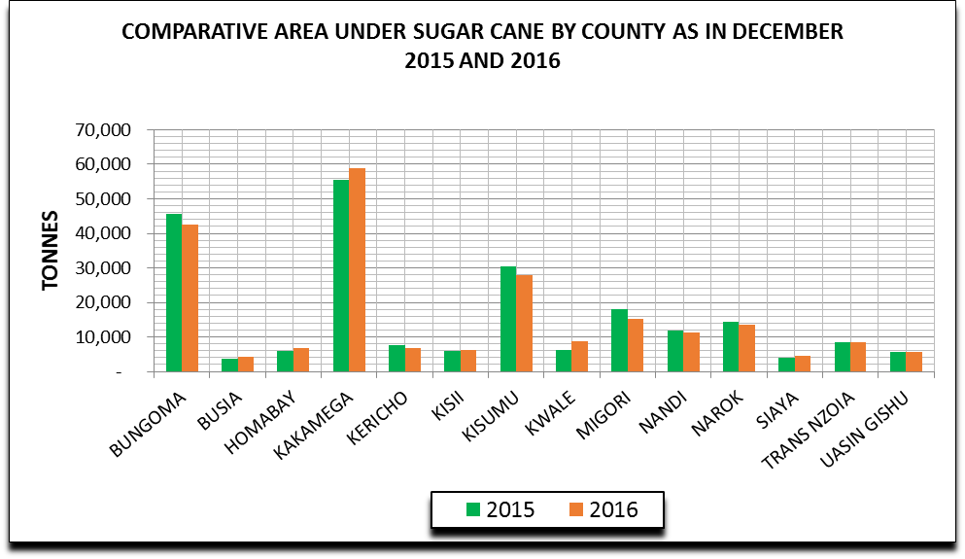*Source: AFA - Sugar Directorate***

**Area harvested and cane yields**

The area harvested increased to 84,956 hectares in the period January – December 2016 compared to 77,830 hectares in the same period last year, giving a 9 per cent increase. The increase is attributed to improved performance at Nzoia, Butali, Sony Sugar, Kwale International and Transmara.

The Sugar industry reported cane yields of 62.95 tonnes per hectare in 2016 compared to 66.41 tonnes per hectare in the same period last year, a decrease of 5%. The decrease in yields is ascribed to the prolonged dry weather conditions leading to poor cane growth and the prevailing cane shortage that resulted into harvesting of immature cane for crushing.

**Cane deliveries**

The total cane deliveries in the period January - December 2016 decreased marginally to 7,142,456 tonnes from 7,164,790 tonnes in the same period 2015. The decrease, despite an increase in the area harvested, is attributed to the low cane yields witnessed in 2016. Kakamega and Bungoma counties supplied the highest volumes of sugarcane, representing 40% of the total cane deliveries. For more details, refer to Figure 3 and Table 4.

Figure 3: Comparative Sugar cane deliveries

**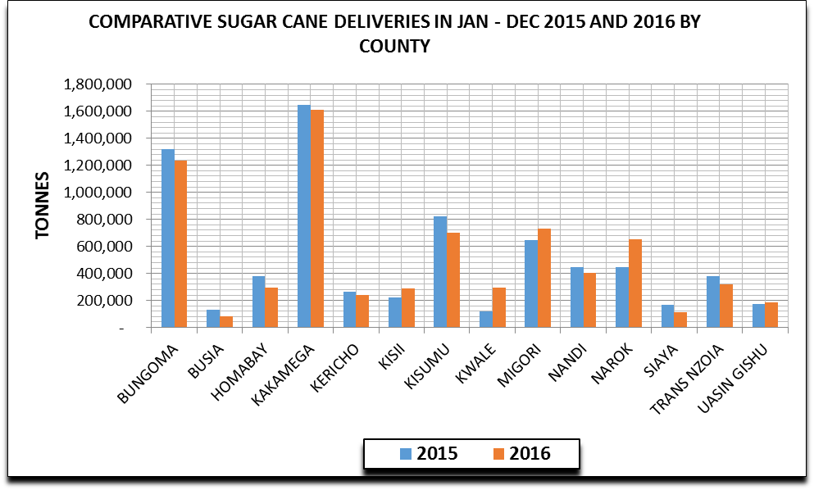*Source: AFA, Sugar Directorate***

**Sugar Production**

The total sugar production from January - December 2016 was 639,741 tonnes. This represented a dismal increase of 0.6 per cent as compared to 635,674 tonnes produced in the same period of 2015. The increase in production was as a result of great improvement by Butali, Nzoia, Kwale and Transmara Sugar Companies. Calculated sugar production by county is shown on Figure 4 and Table 4 below.

Figure 4: Comparative Calculated sugar production by county

**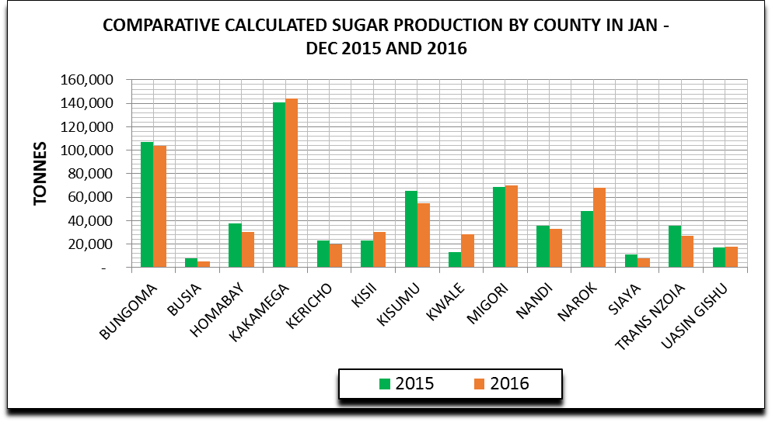*Source: AFA, Sugar Directorate***

**Local Market**

**Cane Prices**

In January – December 2016, sugar cane prices averaged kshs 3,340 per tonne against kshs 3,125 in the same period 2015. The price rise is in tandem with the increasing ex-factory sugar prices and improved compliance with the set payment formula by the millers.

**Ex-factory Sugar Prices**

The ex-factory sugar prices for January – December 2016 averaged Kshs 4,606 per 50kg bag compared to Kshs 3,919 per bag in same period 2015. Price increase is attributed to dropping local sugar stocks against the increasing domestic demand.

**Foreign Trade**

* **Sugar Imports**

Total sugar imports in 2016 were 334,109 tonnes compared to 247,389 tonnes imported in same period 2015, giving an increase of 35%, ascribed to huge imports of table sugar in 2016 (172,888 tonnes) as compared to 99,600 tonnes in the previous year. All the table sugar imports originated from the COMESA region and Uganda while refined sugar was sourced from all over the world under the prevailing trade arrangement.

* **Sugar Exports**

Total sugar exports in 2016 were 98 tonnes compared to 54 tonnes exported in 2015. Sugar exports observed were low due to the fact that Kenya is not self-sufficient in sugar production and its high cost of production. Most of the sugar exports were destined to the neighboring countries.

*Table 4: Sugar Industry*

|  |  |  |  |  |  |  |  |  |
| --- | --- | --- | --- | --- | --- | --- | --- | --- |
| **COUNTY** | **AREA UNDER CANE (HA)** | | **AREA HARVESTED (HA)** | | **CANE DELIVERIES (TONNES)** | | **SUGAR PRODUCTION (TONNES)** | |
|  | **2015** | **2016** | **2015** | **2016** | **2015** | **2016** | **2015** | **2016** |
| BUNGOMA | 45,598 | 42,650 | 15,232 | 19,243 | 1,322,036 | 1,232,410 | 107,255 | 103,870 |
| BUSIA | 3,693 | 4,325 | 1,013 | 1,085 | 129,833 | 81,054 | 7,772 | 4,935 |
| HOMABAY | 5,826 | 6,767 | 5,064 | 4,006 | 378,324 | 292,448 | 37,513 | 30,110 |
| KAKAMEGA | 55,533 | 58,993 | 17,384 | 21,075 | 1,648,360 | 1,610,445 | 140,961 | 144,243 |
| KERICHO | 7,667 | 6,919 | 2,092 | 1,783 | 265,809 | 239,339 | 22,980 | 19,925 |
| KISII | 5,990 | 6,142 | 2,327 | 2,190 | 220,626 | 288,913 | 23,387 | 30,442 |
| KISUMU | 30,507 | 27,925 | 9,624 | 7,527 | 820,752 | 700,878 | 65,649 | 54,623 |
| KWALE | 6,336 | 8,771 | 1,492 | 4,476 | 120,519 | 293,916 | 13,439 | 28,453 |
| MIGORI | 18,142 | 15,207 | 6,853 | 7,391 | 645,714 | 730,338 | 68,637 | 70,184 |
| NANDI | 11,872 | 11,163 | 4,461 | 3,698 | 447,113 | 401,291 | 35,847 | 32,808 |
| NAROK | 14,331 | 13,573 | 4,196 | 4,517 | 445,232 | 654,087 | 48,467 | 67,768 |
| SIAYA | 3,967 | 4,532 | 1,143 | 1,197 | 166,013 | 113,638 | 10,884 | 7,714 |
| TRANS NZOIA | 8,453 | 8,606 | 4,721 | 4,246 | 380,199 | 316,489 | 35,530 | 26,807 |
| UASIN GISHU | 5,689 | 5,773 | 2,226 | 2,524 | 174,260 | 187,211 | 17,354 | 17,859 |
| **TOTAL** | **223,605** | **221,346** | **77,830** | **84,956** | **7,164,790** | **7,142,456** | **635,674** | **639,741** |

1. **Fibre Crops**

**Cotton**

Cotton is produced on a food security front as a source of livelihood for farmers in ASAL areas in 21 counties. It contributes in increasing the households’ incomes and plays a big role in reducing poverty and increasing food security.

The cotton subsector is characterized by a large number of smallholder farmers (40,000) with a low average yield rate of about 572 kg/ha of seed cotton)

The country has an estimated potential of 350,000 hectares suitable for rain-fed crop production and 35,000 hectares of irrigated cotton. This combined potential can produce an estimated 200,000 MT of seed cotton.

*Table 5: Area under cotton and production for 2015 and 2016*

|  |  |  |
| --- | --- | --- |
| YEAR | 2015 | 2016 |
| Area (Ha) | 28,627 | 28700 |
| Seed cotton Production (MT) | 15,726 | 15,800 |
| Seed Cotton price (KES/kg) | 42 | 42 |
| Lint Price | 130-142.32 | 142 |
| No. of Bales(185 kg Lint) | 28,340 | 28,468 |
| Yield (MT/ha) | 0.65 | 550 |
| Value of lint | 744.5 | 748 |

*Source: AFA – Fibre Crops Directorate*

**Sisal**

Sisal is grown predominantly by large scale plantations in the Coast, Eastern and Rift Valley regions in approximately 40,000 Ha. Currently there are ten (10) sisal estates, namely:-

1. Vipingo plantations – Kilifi County
2. Kilifi Plantations – Kilifi County
3. DWA Estate – Makueni County
4. Agro processors International Ltd – Kwale County
5. Teita Estates – Taita Taveta County
6. Voi Plantations – Taita Taveta County
7. Migotyo plantations – Nakuru County
8. Majani Mingi Sisal Estate – Baringo County
9. Athinai plantation – Baringo County
10. Lomolo Ltd – Baringo County

The area under smallholder cannot be ascertained as many farmers are scattered in Kitui, Makueni, Homabay and Migori counties where the crop is mainly grown along the boundaries. This area is estimated to be 2,000 ha.

Figure 5: Percentage distribution of key Sisal growing counties

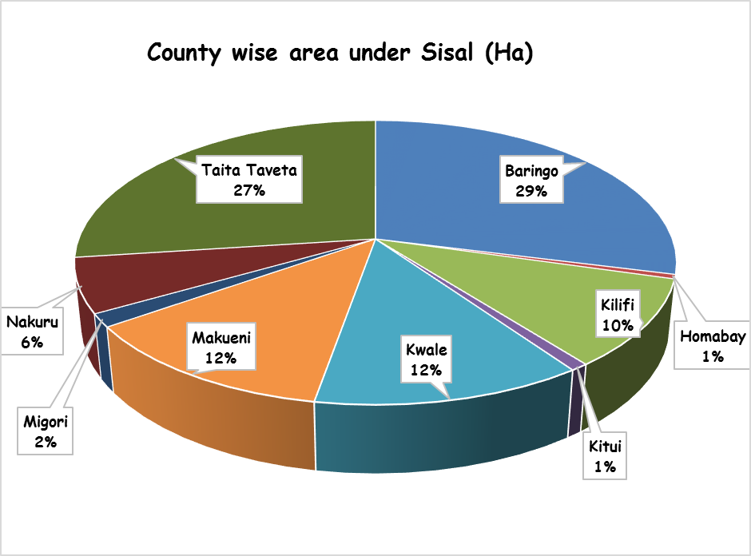 *Source: AFA – Fibre Crops Directorate*

**Sisal Production**

During the period under review, a total of 24,263 metric tonnes of sisal was produced last year compared to 25,310 metric tonnes produced in 2015 representing a decline of 4 per cent. This decrease is attributed to prolonged dry weather conditions experienced in the country.

**Sisal exports**

Under the review period, a total of 21,460 mt of sisal fibre was exported in 2016 worth Kshs. 4,176,764,790 compared to 21,240.84 metric tonnes worth Kshs. 3,594,951,541 exported in the previous year. The increase is attributed to favorable prices due to the high demand of the sisal fibre and the emergence of new markets such as Iraq, Qatar and Slovenia countries. The key markets for the Kenyan sisal fibre are Saudi Arabia, Nigeria, China, Morocco and Egypt.

*Table 6: Sisal fibre exports by value and volume*

|  |  |  |  |  |
| --- | --- | --- | --- | --- |
| **MONTH** | **Export Volume (mt)** | | **Export Values (Kshs)** | |
| **2016** | **2015** | **2016** | **2015** |
| January | 1,833.40 | 1,938.10 | 364,664,742.00 | 270,496,151.50 |
| February | 2,203.50 | 1,519.50 | 417,603,852.00 | 231,297,652.00 |
| March | 1,910.75 | 2,175.30 | 382,457,377.62 | 337,335,908.00 |
| April | 1,723.60 | 2,041.80 | 332,243,960.00 | 310,500,030.00 |
| May | 2,251.90 | 2,129.60 | 437,632,805.00 | 330,163,163.00 |
| June | 1,712.80 | 1,723.70 | 347,700,880.00 | 284,389,905.00 |
| July | 1,558.20 | 1,530.20 | 304,217,223.00 | 279,468,668.50 |
| August | 1,980.20 | 1,945.24 | 383,717,750.00 | 355,591,743.00 |
| September | 1,671.53 | 1,386.80 | 323,649,225.00 | 258,014,820.00 |
| October | 1,645.83 | 1,837.60 | 320,911,950.00 | 362,460,307.00 |
| November | 1,931.90 | 1,442.80 | 367,883,353.00 | 269,059,033.00 |
| December | 1,036.00 | 1,570.20 | 194,081,672.00 | 306,174,160.00 |
| **TOTALS** | **21,459.61** | **21,240.84** | **4,176,764,789.62** | **3,594,951,541.00** |

*Source: AFA – Fibre Crops Directorate*

1. **Pyrethrum & other industrial crops**

**Area under Pyrethrum production**

Pyrethrum is one of the most important strategic enterprises in Kenya’s economy, grown in 19 counties namely: Meru, Nyandarua, Nyeri, Kiambu, Embu, Trans Nzoia, Uasin Gishu, Bungoma, West Pokot, Elgeyo Marakwet, Nandi, Baringo, Laikipia, Nakuru, Narok, Kericho, Bomet, Kisii and Nyamira. These counties are further re-grouped into 4 pyrethrum growing regions namely; Nyanza, South Rift, North Rift and Central/Eastern.

Figure 6: Area under Pyrethrum

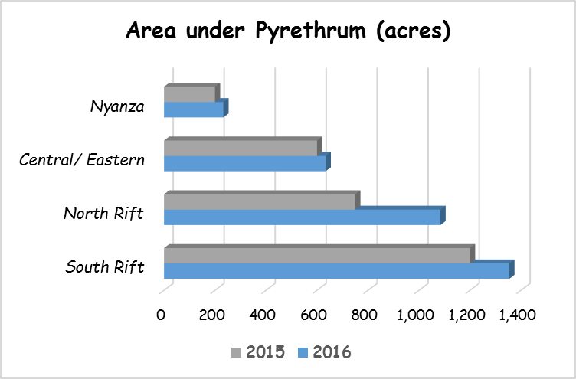

The total area under pyrethrum production increased by 555 acres from 2,750 acres recorded in 2015 to 3,305 acres recorded in 2016. This was attributed to the funding of Kshs. 30 Million from the Ministry of Agriculture Livestock and Fisheries for clonal material distribution amongst the farmers.

***Strategies to enhance pyrethrum production in Kenya***

The following interventions need be put in place to address the constraints facing the pyrethrum growers in order to boost production and reverse the decline:

1. Aggressive distribution of planting material on time;
2. Prompt payment for dry flowers deliveries by the growers;
3. Capacity building within the County government; and
4. Partnership with both the national (MOALF) and county governments to promote pyrethrum growing in both the traditional and non-traditional areas.
5. Improvement of factory processing efficiency

***Dry flowers Production***

In the period under review, a total of 239,309 kilograms of dry flowers were delivered to Nakuru for processing. This represented a decrease of 14 per cent compared 278,787 kilograms delivered in the same period in 2015. This decline was attributed to unfavourable weather conditions experienced in the pyrethrum growing areas and delay in offsetting the growers’ arears.

Figure 7: Dry flowers delivered for the year 2015 and 2016

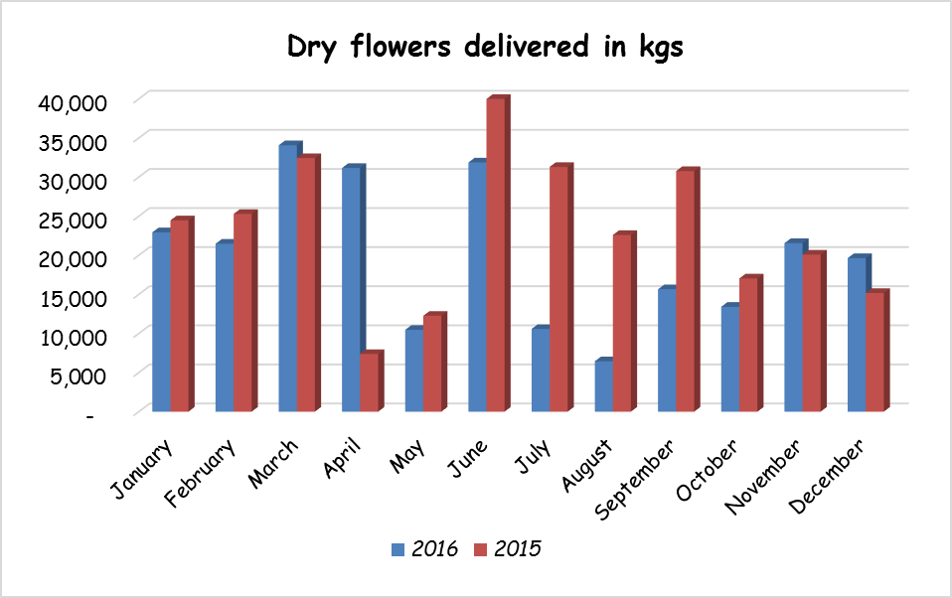

*Table 7: Dry flowers production per county in 2015 and 2016*

|  |  |  |  |  |  |
| --- | --- | --- | --- | --- | --- |
| **Region** | **County** | **January - December** | | **Calculated Area (acres)** | |
| **2015** | **2016** | **2015** | **2016** |
| South Rift | KERICHO | 2,983 | 3,181 | 30.5 | 49.8 |
| NAKURU | 105,294 | 72,585 | 1078.3 | 1136.2 |
| NAROK | 3,233 | 2,537 | 33.1 | 39.7 |
| BOMET | 5,667 | 8,196 | 58.0 | 128.3 |
| ***Sub Total*** | ***117,177*** | ***86,499*** | ***1200.0*** | ***1354.0*** |
| North Rift | BARINGO | 4,760 | 3,584 | 28.2 | 31.6 |
| ELGEYO MARAKWET | 8,459 | 4,233 | 50.2 | 37.3 |
| NANDI | 22 | 573 | 0.1 | 5.1 |
| TRANS NZOIA | 54 | 1,673 | 0.3 | 14.8 |
| UASIN GISHU | 14,503 | 5,915 | 86.0 | 52.2 |
| WEST POKOT | 98,303 | 93,357 | 583.2 | 823.6 |
| BUNGOMA | 314 | 13,537 | 1.9 | 119.4 |
| ***Sub Total*** | ***126,415*** | ***122,872*** | ***750.0*** | ***1084.0*** |
| Nyanza | KISII | 7,042 | 7,196 | 144.7 | 153.7 |
| NYAMIRA | 2,693 | 3,711 | 55.3 | 79.3 |
| **Sub Total** | **9,735** | **10,907** | **200.0** | **233.0** |
| Central/ Eastern | KIAMBU | 1,607 | 1,742 | 37.9 | 58.0 |
| NYANDARUA | 19,405 | 12,167 | 457.3 | 405.3 |
| NYERI | 1,769 | 2,075 | 41.7 | 69.1 |
| MERU | 729 | 521 | 17.2 | 17.4 |
| LAIKIPIA | 1,950 | 2,526 | 46.0 | 84.2 |
| ***Sub Total*** | ***25,460*** | ***19,031*** | **600.0** | **634.0** |
| ***Grand Total*** | | ***278,787*** | ***239,309*** | ***2,750*** | ***3,305*** |

***PY content***

The average PY content during the above period in 2016 was 1.39 % representing a marginal increase of 0.04 per cent compared to the same period in 2015 which was 1.35%. This was attributed to the reduction of the waiting period required to achieve the minimum threshold of 100 MT before processing of flowers is done.

**Growers Payments**

A total of Kshs. 41,979,069 was paid out to the pyrethrum growers for the period January - December 2016 compared to Kshs. 59,064,507 paid out in the same period of 2015. This represents 29 per cent decline that was attributed to the reduction of flowers delivered to the factory for processing as a result of delay in clearing farmers’ outstanding arrears.

*\*\* Note: The recent separation of functions between the commercial wing pyrethrum Processing Company of Kenya (PPCK) and the regulator Pyrethrum and Other industrial Crops Directorate (POICD) mandates the directorate to also regulate other new sub sector processors as well as collect, collate and analyze pyrethrum industry statistics and maintain a data base for the pyrethrum industry*

1. **Nuts and Oil Crops**

Under the review period, the area under nuts and oils crops reduced marginally from 100,402 hectares recorded in 2015 to 94,808 hectares recorded in 2016. This was mainly attributed to the dry weather conditions experienced in the country in 2016 and cutting down of productive nuts and oil crops trees especially in the coastal region.

The overall production decreased by 18 per cent from 187,108 metric tonnes valued at Kshs. 5,858 Million in 2015 to 153,133 metric tonnes worth Kshs. 5,529 Million recorded in 2016. Other than the dry weather conditions and the cutting down of productive nuts and oil crops trees, the economic slump in some of the world importers of nuts and nuts products adversely affected the productivity of the sub sector.

*Table 8: County wise Area and Production of Nuts and Oil crops 2015 and 2016*

|  |  |  |  |  |  |  |  |
| --- | --- | --- | --- | --- | --- | --- | --- |
| **CROP** | **COUNTY** | **Area (Ha)** | | **Quantity (Mt)** | | **Value (Kshs.)** | |
| **BAMBARA GROUND NUTS** | **2016** | **2015** | **2016** | **2015** | **2016** | **2015** |
| KILIFI | 0 | 4 | 0 | 3 | 0 | 160,000 |
| KWALE | 10 | 10 | 60 | 100 | 3,600,000 | 6,000,000 |
| MOMBASA | 0 | 2 | 0 | 3 | 0 | 90,000 |
| **Total** | **10** | **16** | **60** | **106** | **3,600,000** | **6,250,000** |
| **CASHEW NUTS** | KILIFI | 13,536 | 13,896 | 6,585 | 6,463 | 206,649,443 | 201,644,664 |
| KWALE | 7,610 | 8,710 | 4,698 | 7,512 | 187,920,000 | 300,480,000 |
| LAMU | 0 | 6,013 | 0 | 4,810 | 0 | 288,624 |
| TAITA TAVETA | 0 | 7 | 0 | 4 | 0 | 136,500 |
| TANA RIVER | 133 | 128 | 75 | 70 | 2,850,000 | 2,340,000 |
| THARAKA NITHI | 5 | 4 | 46 | 48 | 1,380,000 | 1,440,000 |
| **Total** | **21,284** | **28,758** | **11,404** | **18,908** | **398,799,443** | **506,329,788** |
| **COCONUT** | BUSIA | 11 | 11 | 2 | 2 | 30,000 | 32,000 |
| KILIFI | 27,217 | 28,321 | 54,313 | 66,968 | 814,692,000 | 1,071,491,200 |
| KWALE | 14,361 | 17,484 | 30,821 | 48,390 | 462,318,000 | 774,240,000 |
| LAMU | 5,215 | 3,995 | 5,444 | 9,988 | 108,880,000 | 199,750,000 |
| MOMBASA | 102 | 100 | 153 | 150 | 2,295,000 | 2,400,000 |
| SIAYA | 10 | 0 | 40 | 0 | 600,000 | 0 |
| TAITA TAVETA | 96 | 48 | 474 | 285 | 7,110,000 | 4,560,000 |
| TANA RIVER | 389 | 631 | 389 | 631 | 5,835,000 | 12,620,000 |
| **TOTAL** | **47,400** | **50,590** | **91,636** | **126,414** | **1,401,760,000** | **2,065,093,200** |
| **GROUND NUTS** | BARINGO | 531 | 240 | 655 | 1,416 | 69,090,009 | 77,136,000 |
| BUNGOMA | 606 | 1,000 | 843 | 1,869 | 81,509,600 | 92,907,000 |
| BUSIA | 1,093 | 1,030 | 1,078 | 1,032 | 227,220,633 | 102,488,833 |
| ELGEYO MARAKWET | 110 | 58 | 273 | 141 | 27,339,300 | 11,892,500 |
| HOMABAY | 6,426 | 5,211 | 5,598 | 3,965 | 627,905,613 | 424,673,000 |
| KAKAMEGA | 1,025 | 877 | 1,724 | 1,700 | 451,465,500 | 183,761,000 |
| KILIFI | 6 | 0 | 2 | 0 | 152,005 | 0 |
| KISII | 213 | 216 | 272 | 255 | 11,158,000 | 10,848,000 |
| KISUMU | 1,290 | 1,439 | 478 | 1,280 | 70,038,000 | 180,009,000 |
| KWALE | 63 | 57 | 208 | 405 | 19,579,000 | 22,698,000 |
| LAMU | 78 | 231 | 25 | 347 | 3,750,000 | 13,860,000 |
| MACHAKOS | 2 | 2 | 15 | 12 | 1,032,000 | 980,000 |
| MAKUENI | 3 | 0 | 30 | 0 | 30,000 | 0 |
| MERU | 3,942 | 3,348 | 4,478 | 3,872 | 313,613,000 | 270,645,900 |
| MIGORI | 553 | 153 | 384 | 70 | 14,808,211 | 1,819,505 |
| NANDI | 2 | 0 | 2 | 0 | 2,000,000 | 0 |
| NYAMIRA | 3 | 4 | 2 | 2 | 259,200 | 345,600 |
| SIAYA | 2,420 | 2,006 | 1,599 | 1,538 | 35,951,267 | 134,566,000 |
| TAITA TAVETA | 41 | 10 | 123 | 30 | 8,430,000 | 300,000 |
| TANA RIVER | 54 | 60 | 10 | 25 | 1,200,000 | 1,125,000 |
| THARAKA NITHI | 435 | 230 | 3,760 | 3,016 | 40,830,000 | 313,620,000 |
| TRANSNZOIA | 17 | 10 | 170 | 100 | 8,500,000 | 5,000,000 |
| VIHIGA | 48 | 0 | 13 | 0 | 1,338,000 | 0 |
| WEST POKOT | 41 | 30 | 75 | 40 | 6,680,000 | 3,700,000 |
| **TOTAL** | **19,001** | **16,210** | **21,816** | **21,117** | **2,023,879,337** | **1,852,375,338** |
| **MACADAMIA NUTS** | BARINGO | 295 | 453 | 681 | 1,287 | 40,881,960 | 90,101,200 |
| BUNGOMA | 3 | 3 | 31 | 31 | 1,860,000 | 2,170,000 |
| BUSIA | 129 | 15 | 0 | 0 | 0 | 0 |
| ELGEYO MARAKWET | 1 | 1 | 1 | 1 | 36,000 | 56,000 |
| EMBU | 790 | 773 | 5,675 | 5,619 | 340,500,000 | 393,330,000 |
| KAKAMEGA | 1 | 1 | 1 | 1 | 72,000 | 70,000 |
| KIRINYAGA | 214 | 165 | 1,671 | 600 | 100,260,000 | 42,000,000 |
| LAIKIPIA | 7 | 6 | 4 | 4 | 240,000 | 280,000 |
| MACHAKOS | 127 | 100 | 2,004 | 1,744 | 120,240,000 | 122,087,000 |
| MERU | 877 | 525 | 9,068 | 2,903 | 544,080,000 | 203,196,000 |
| MURANGA | 384 | 393 | 3,776 | 2,131 | 226,566,600 | 149,195,200 |
| NYERI | 107 | 68 | 364 | 2,000 | 21,840,000 | 140,000,000 |
| TAITA TAVETA | 46 | 257 | 253 | 1,305 | 15,180,000 | 91,350,000 |
| THARAKA NITHI | 170 | 170 | 980 | 840 | 58,800,000 | 58,800,000 |
| TRANSNZOIA | 14 | 13 | 166 | 162 | 9,960,000 | 11,340,000 |
| **TOTAL** | **3,164** | **2,944** | **24,675** | **18,628** | **1,480,516,560** | **1,303,975,400** |
| **SIMSIM** | BUNGOMA | 11 | 134 | 19 | 206 | 1,800,000 | 17,790,000 |
| BUSIA | 255 | 28 | 73 | 8 | 7,560,000 | 1,120,000 |
| HOMABAY | 3 | 4 | 1 | 2 | 240,000 | 320,000 |
| KAKAMEGA | 4 | 1 | 2 | 1 | 145,000 | 30,000 |
| KISUMU | 0 | 12 | 0 | 8 | 0 | 1,200,000 |
| LAMU | 3,160 | 1,302 | 3,193 | 1,602 | 191,580,000 | 96,120,000 |
| MANDERA | 146 | 148 | 72 | 73 | 5,290,000 | 5,350,000 |
| SIAYA | 99 | 17 | 6 | 7 | 120,000 | 620,100 |
| TANA RIVER | 270 | 240 | 170 | 30 | 13,600,000 | 1,200,000 |
| **TOTAL** | **3,948** | **1,885** | **3,535** | **1,936** | **220,335,000** | **123,750,100** |

**Compilation**

The report was compiled by;

1. Joseph Thaiyah Tea Directorate
2. Joel Atuti Pyrethrum Processing Company of Kenya
3. Jason Mugo Sugar Directorate
4. Jeremiah Omung`ala Nuts & Oil Crops Directorate
5. Macharia Kabui Fibre Crops Directorate
6. David Kendagor Coffee Directorate
7. Elisha Mtogo AFA Research, Planning & Strategy
8. Wekesa Khisa Food Crops Directorate